ALU

Truth table

Wr =1 | Writes the data into the reg
Wr = 0 | Reads the data from the reg

Note: i)only one port to write
ii) two ports a and b to write

Output

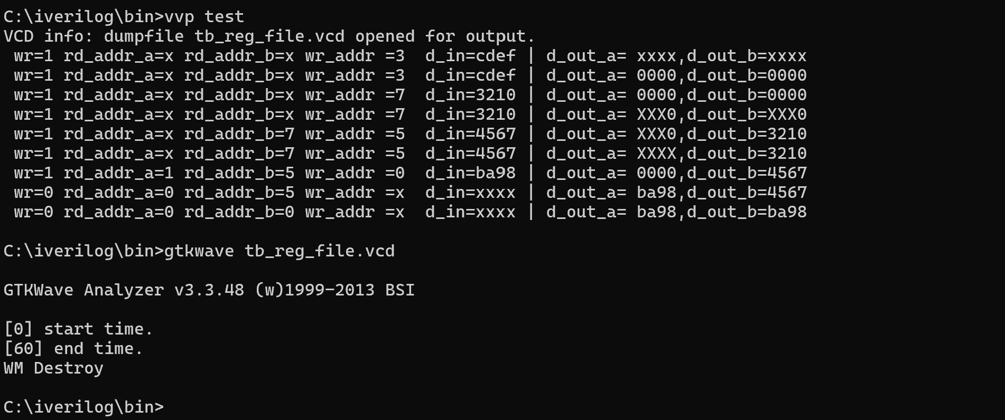

GTKwave

